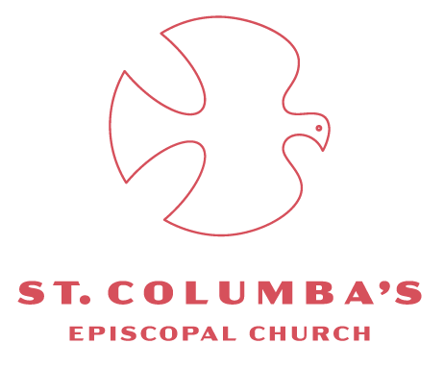

***Get Up!***

*The Rev. Joshua Daniel, Ph.D.*

*St. Columba’s Episcopal Church*

*Washington, D.C.*

*November 24, 2024*

***Christ the King***

[Mark 14:12-42](https://www.biblegateway.com/passage/?search=Mark%2014&version=NRSVUE)

[*Scriptural Illumination here*](https://www.youtube.com/live/gkTE1AAgFGo?si=k-y5qvVkZ1SvQbSd&t=1640)

*_______*

We’re trying something new this morning. We’ve come to the end of the liturgical year today – which means we’re putting the Gospel of Mark away for two years. *Bye bye Mark!*

I thought we might end our year reading Mark by giving him – by giving Jesus, really – the last word.

In just a moment we’ll sing Psalm 93. Then I’ll reenact Mark’s story of the last supper and the night of prayer in Gethsemane – a word-for-word recitation of it.

But before we begin I’d like to draw your attention to something in this passage – a tool that Mark uses throughout the Gospel. In this passage he speaks in double voice.

The first voice – and the most recognizable – is Jesus speaking to his disciples. The first voice just is the characters of the gospel speaking directly to each other.

The second voice is Jesus speaking directly to you. Mark almost always has Jesus speaking in both voices at the same time. Speaking directly to his disciples and speaking directly to you.

The gospel is not just for those who happened to be living during his life; Jesus speaks to Christians for all time.

Mark meant for the church to read and reread this text. To wonder at it; to hear it and truly believe that Jesus is speaking to us. To you. And if he is speaking to you and if you do truly believe it, then you must also ask, *What will I do with these words? How will I answer the command of Jesus?*

❃

*What command?* you might wonder!

At the last supper Jesus takes his entire life’s ministry and lays it before his friends, his disciples. As he does throughout the gospel he clarifies his message by contrasting two simple images against each other. In this story the images of contrast are feast and betrayal.

At the last supper Jesus lays down on the altar the great thanksgiving; the Eucharistic bread and wine. He lays down the feast of abundance. His entire ministry of healings, resurrections; all the moments of forgiveness.

So too does Jesus lay down his tears and dread. To those gathered around his table, he explicitly names the coming betrayal of one and the coming failure of all. Jesus lays down rejection itself, offering it up to God; all the frustrated and upended plans; all the blindness and hard-heartedness. Jesus was hated, feared, even laughed at.

In the last supper Jesus lays both images before the disciples. Which will they choose? The life of division and chaos and death. Or will they choose healing, wholeness, and new life? The superabundance of the table or the betrayal of men?

The disciples and the church, of course, chose both. Peter will show courage and follow Jesus right into the imperial courtyard, into the very heart of darkness. But then he’ll falter, plead ignorance, deny, and flee. But, then, the resurrected Jesus will pick Peter up off the ground and send him out again, forgiven, as chief evangelist of the new life in Jesus. And so it goes.

❃

In Gethsemane Jesus shows us what life with God is like.

First he retreats into the garden and rests there. Then he prays. He offers to the Father his open and broken heart. Jesus has confidently told others that “For God all things are possible” (Mark 9:23; 10:27). And so he waits for God to break in and save him. And he waits. And … there is no answer. So he prays again. And there is no answer. Three times he prays. And three times the Father does not answer the Son.

Then Jesus rises. And he calls his disciples to rise. To be a risen people.

He finds us in our slumber. Down cast, discouraged, and abandoned. He calls us to prayer. He calls us to *Keep Awake!* Then he sends us out with these words: *Get up, let us be going!*

Together we go into the world to speak of the love of God, to proclaim with power and courage.

Rest. Pray. Rise.

The world needs you. And you need God. Amen.